USGS STANDARD EQUIPMENT INSTALLATION PLAN

(TYPE OF INSTALLATION)
(ROUTE) OVER (WATERBODY)
(PARTNERING AGENCY)
(Latitude, Longitude)

(COUNTY NAME) COUNTY, SOUTH CAROLINA

(INSERT PICTURE OF PROJECT)

(Date)
Prepared by: (Name)
(Contact Information)

- Scope of work

The United States Geological Survey (USGS) has received a request from the (requesting Agency’s name) to install a (Type of Equipment) at the (Waterbody) at (Route) SC 41 near (Selected), SC in (County Name) County. The (type of equipment) will be used to (description of use). Other sensors will be attached to bridge as determined to be necessary.

- Method of attachment

All work done by the USGS will follow their standard practices and guidance from the Bridge Maintenance Office and Hydraulic Design Support Office. The USGS will attach a water level gage and wire weight gage to the downstream barrier wall over the middle of the stream. The water level gage and wire weight gage will be attached using 4 stainless steel anchor bolts with epoxy and wire weight gage with 4 anchor bolts. All concrete attachments will be attached with wedge anchors and sealed with an epoxy sealant. All materials will be aluminum, stainless steel, or galvanized steel and weight less than 100 pounds.

- Site information

The USGS will send SCDOT the datum, datum elevation, drainage area, and other elevations collected by the USGS after the installation is complete.

- Figures

(List all figures)

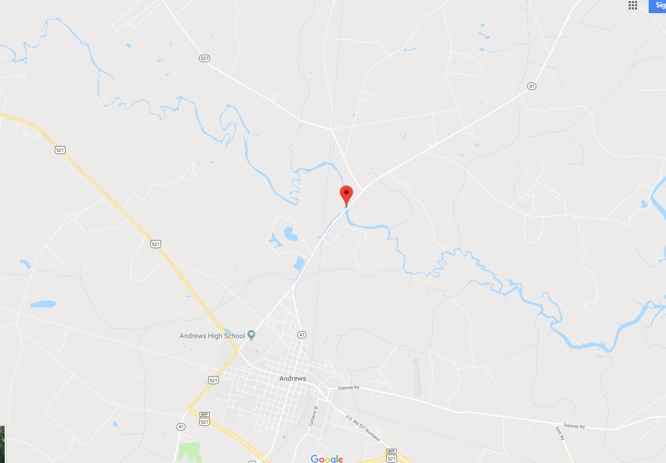
Figure 1. Location map of Black River at SC 41 near Andrews, SC in Georgetown County

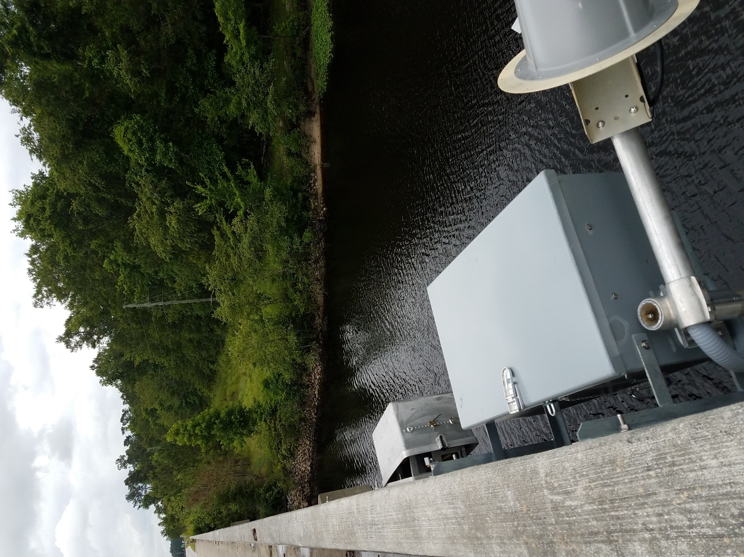
Figure 2. Example gage similar to Black River at SC 41 near Andrews, SC in Georgetown County

ATTACHMENT 1

(Plan and Profile Sheet showing proposed location of the installation.)

